Covered Wagon Craft
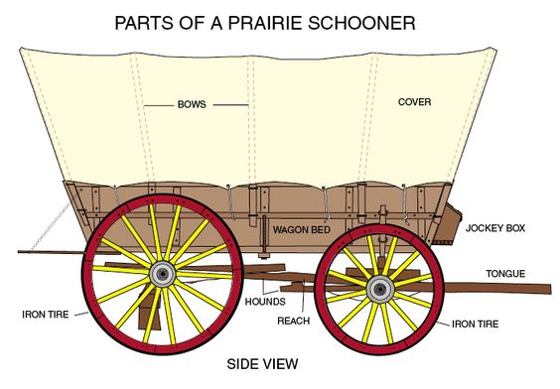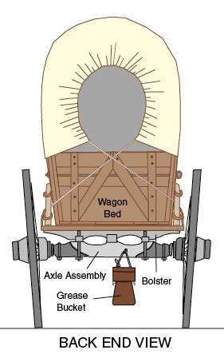

You will need stiff-ish paper (cardstock is best, but quality construction paper does in a pinch), tissue paper or thin white fabric for the cover, cardboard, and two bamboo skewers for the axle. Also a ruler, pen, scissors, glue.

Start with making the wagon box with the stiff-ish paper. Use your ruler and pen to make the box bottom and sides on the paper. The illustration below (not to scale) shows how to draw a two-dimensional shape that can be folded up into an open topped box. Black line shows the paper edge and red lines are to be drawn in. You can make it any size you like, or aim for around 6 inches by 4 inches.

Once drawn, take your scissors and cut along the lines shown in blue (below). Discard the portion shaded grey.

Fold along the lines indicated in red, creating a box shape. The yellow shaded areas are the flaps that will be folded and glued to the sides to hold the box together. This is your wagon box.

Using some more stiff-ish paper, cut long thin strips (10 inches long) to serve as the bows (the curved frame that holds up the cover). Use glue to secure the ends of the bows to the inside of the wagon box.

Before you cover your wagon, the wheels need to go on. The wheels themselves are cut from a thicker cardboard (circle drawn using a cup as a guide and cut out with scissors). Mark the center of each circle and punch a hole through with a bamboo skewer (kids might need help with this).
Holes also need to be made in the wagon box to allow the wheel axles through. We used a bit of tape to strengthen the area, and then pushed through the skewer along the bottom corner of the box (be careful and get help with this).
With the axle skewer all the way though the box, push the wheels onto either end.
Trim the skewer to just longer than the wheel. A drop of glue where the wheel meets the axle (skewer) will help the wheels stay in place.
Tissue paper (or thin white fabric) goes over top the bows and secured with glue. Trim off any hang-y over bits.
Now, once you have your wagon ready to roll, you can make supplies to go inside the wagon and a couple of pioneers to ride!

